*UNVEILIBG MARKET INSIGHTS : ANAIYSING SPENDING BEHAVIOUR AND IDENTIFYING OPPORTUNITIES FOR GROWTH*

INTRODUCTION

IN today's dynamic and ever-evolving market landscape, understanding consumer spending behavior is pivotal for businesses aiming to thrive and expand. The ability to dissect market insights and decipher the intricate patterns of how consumers allocate their resources is not just a valuable skill; it's a necessity. This process of unraveling the intricacies of spending behavior goes beyond mere data analysis; it delves into the psyche of consumers, unveiling the reasons behind their purchasing decisionsk

* 1. OVERVIEW

Analyzing spending behavior and identifying opportunities for growth is a strategic process that businesses employ to understand how consumers allocate their resources and make purchasing decisions. This analysis involves the systematic examination of various factors influencing consumer choices, such as economic trends, social influences, and technological advancements.

* 1. PURPOSE

The purpose of analyzing spending behavior and identifying opportunities for growth is multifaceted and pivotal for businesses operating in today's competitive markets. Here are the key purposes behind this strategic endeavor:

2.PROBLEM STATEMENT & DESIGN THINKING

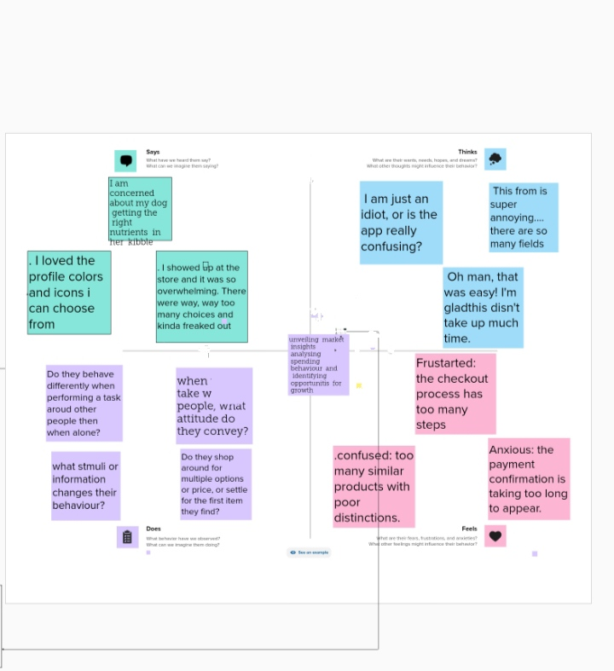 2.1 Empathy map

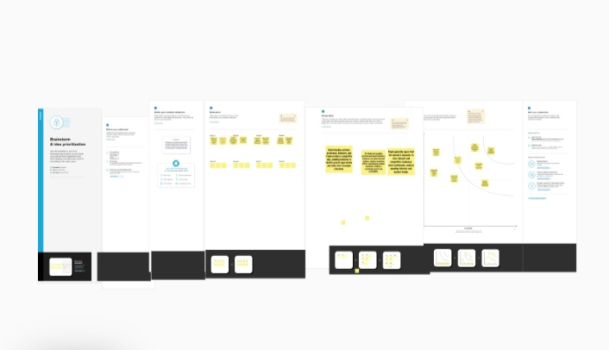

2.2 Ideation & brainstorming

1. RESULT

* 1. KPI'MILK

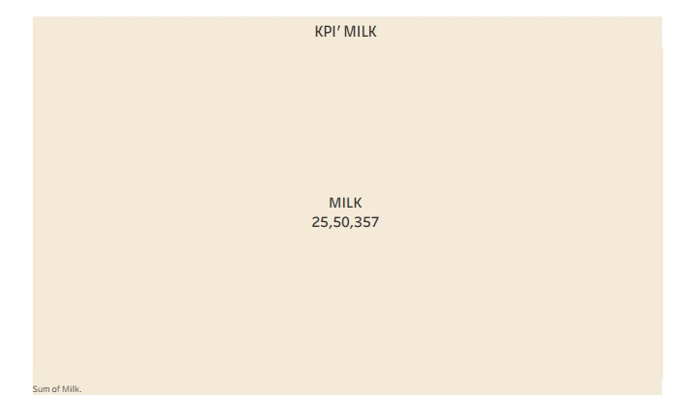

3.2 KPI'GROCERY

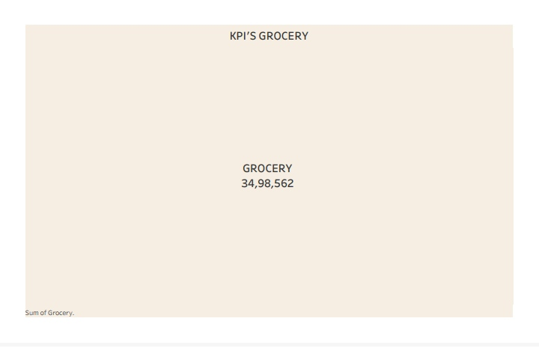

3.3 KPI' FRESH

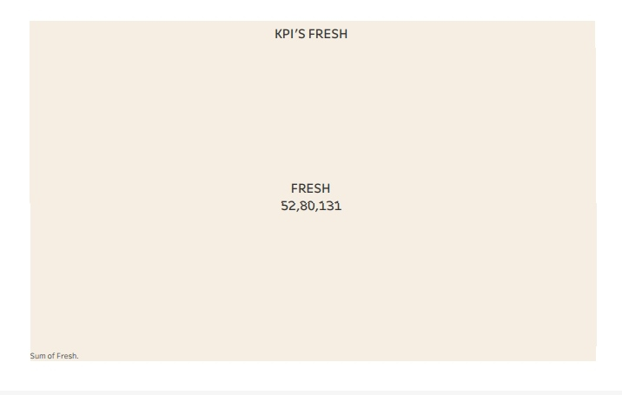

3.4 **REGION WISE DETERGENT PAPER AND GROCERY**

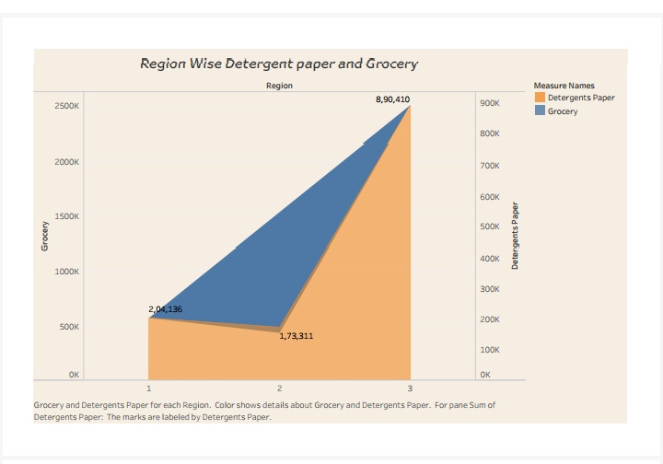

3.5 CHENNEL WISH DETERGENT PAPER AND GROCERY

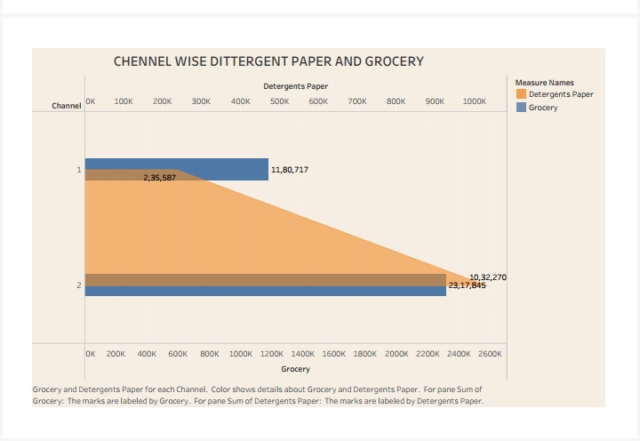

3.6 REGION WISE MILK

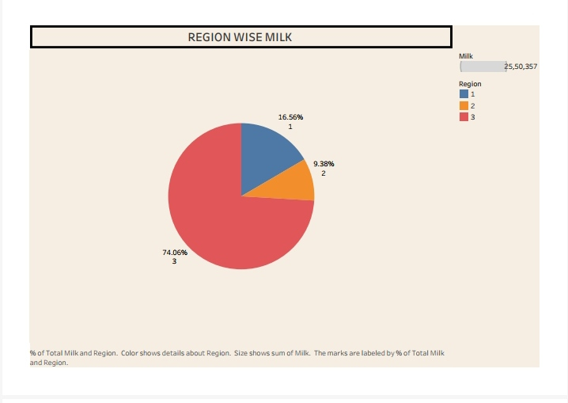

**3.7 CHENNEL WISH FROZEN AND DETERGENT PAPER**

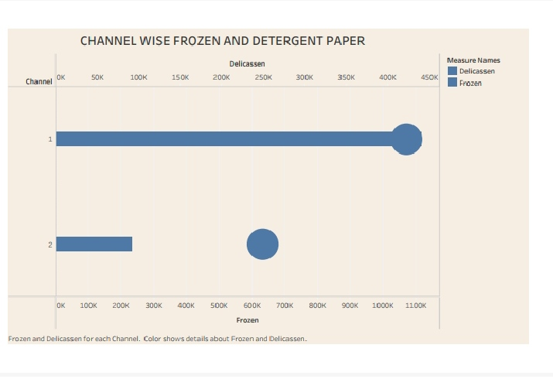

**3.8 REGION WISE DELICATESSEN**

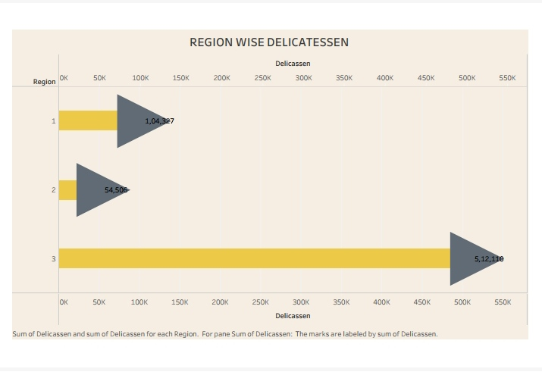

**3.9 REGION WISE DELICASSEN DETERGENT PAPER**

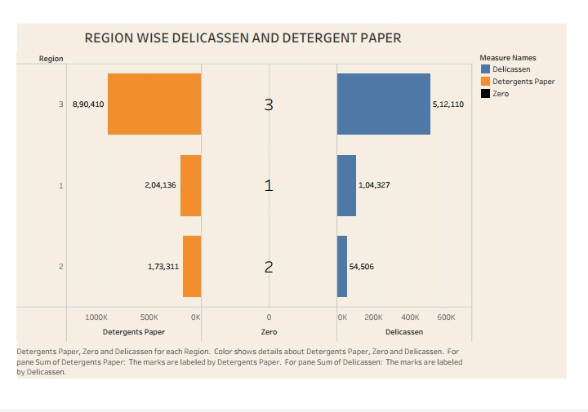

DASHBOARDT

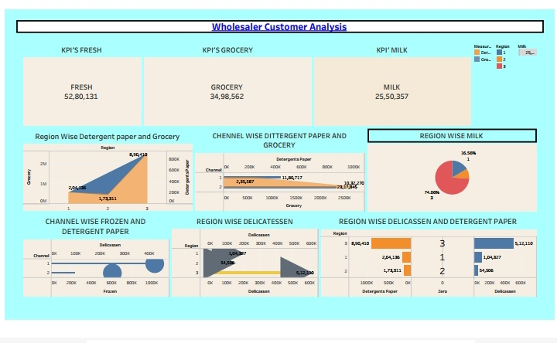

WHOLESALER CUSTOMER ANALYSIS

STORY

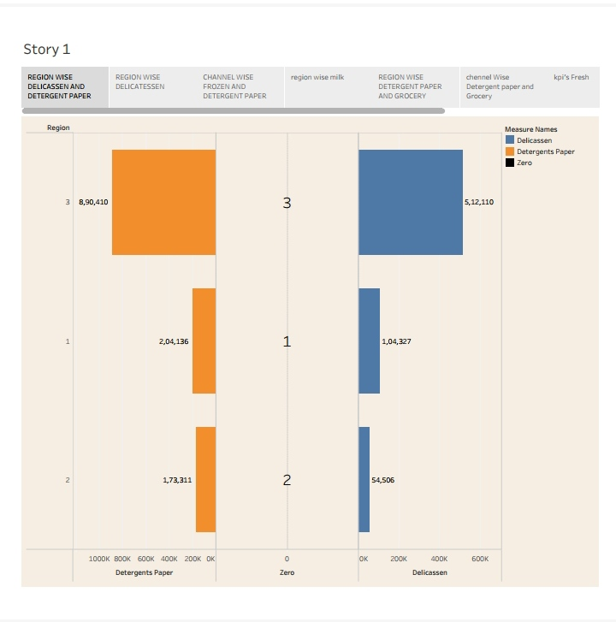

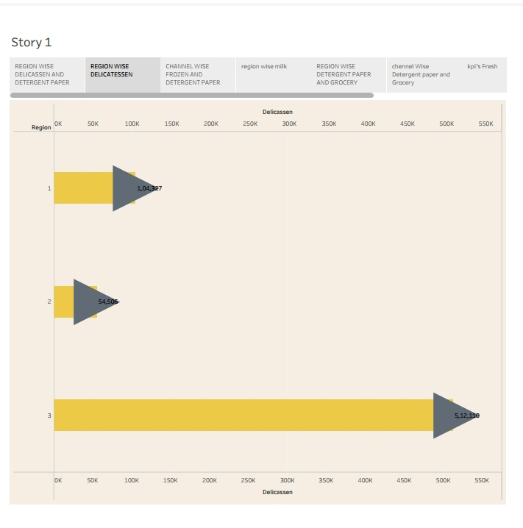

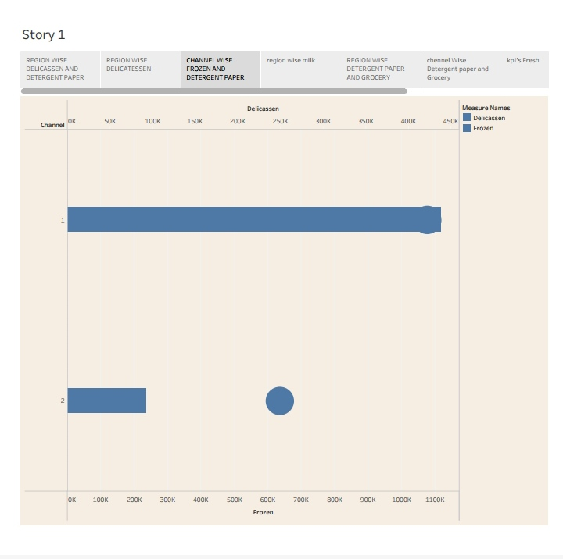

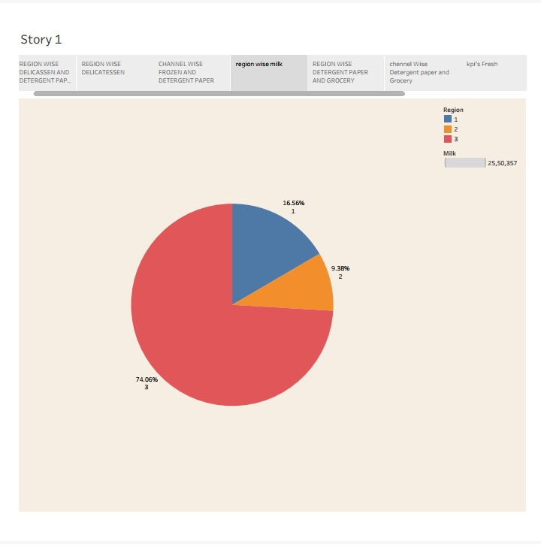

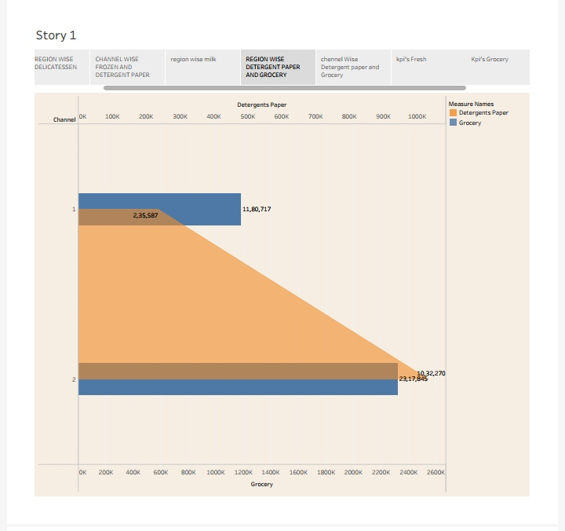

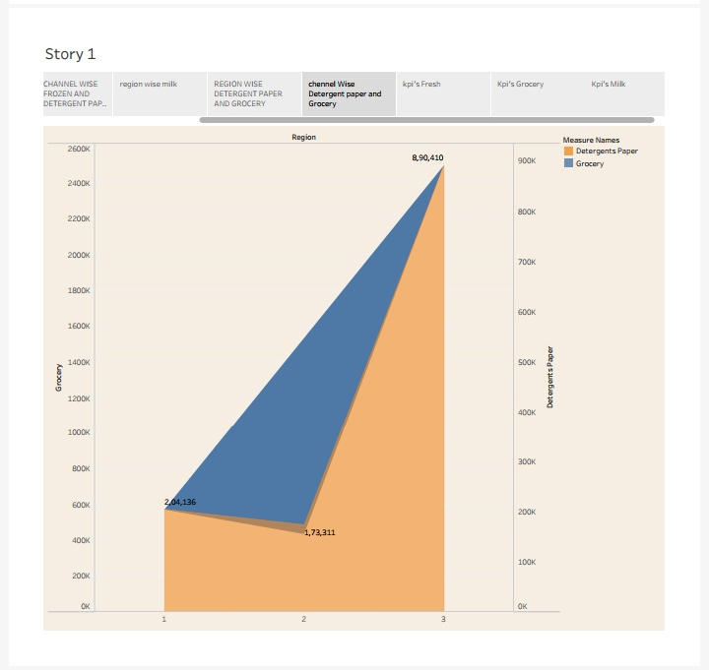

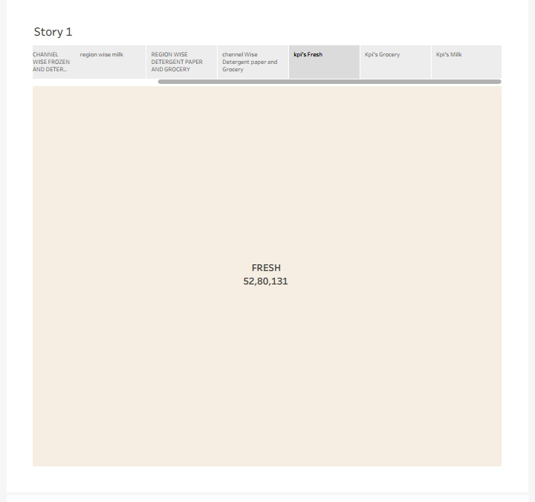

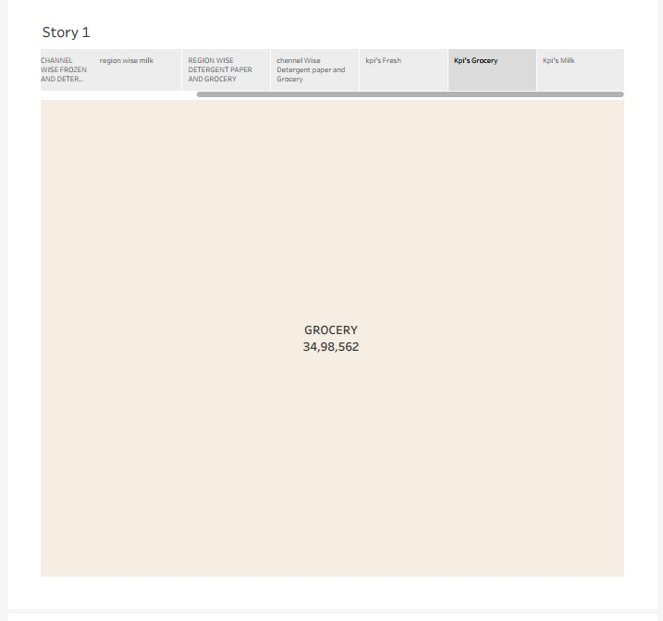

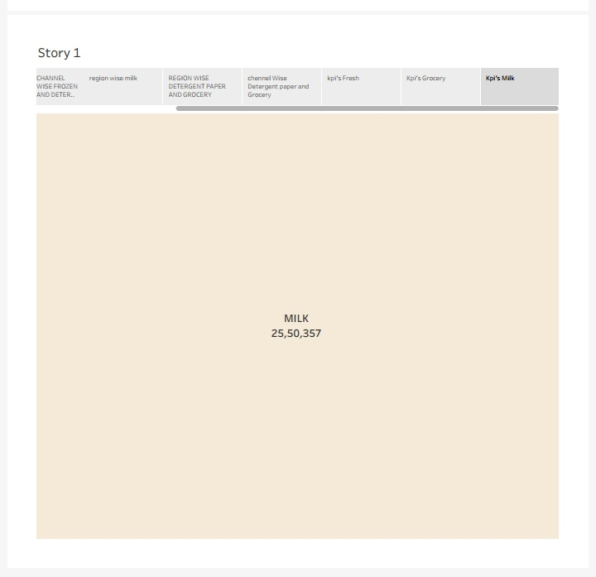

ADVANDAGES & DISADVANDAGES

4.1 ADVANDAGES

* Businesses can make strategic decisions based on accurate insights into consumer preferences and market trends.
* Tailoring marketing efforts to specific consumer segments increases the efficiency and effectiveness of marketing campaigns.
* Understanding spending patterns helps in refining products or services to better meet consumer demands and expectations.
* Businesses can stay ahead of competitors by identifying and capitalizing on emerging market trends.
* Enhanced understanding of customer behavior allows businesses to improve customer experience, fostering loyalty and repeat business
* Anticipating market shifts and economic changes enables businesses to adjust their strategies, reducing the impact of unforeseen events.
* Data-driven insights can inspire innovation, leading to the development of new products or services that cater to evolving consumer needs.

DISADVANDAGES

* Collecting and analyzing consumer data raises privacy concerns, requiring businesses to handle data responsibly and ethically.
* Ensuring the accuracy of data is crucial; erroneous data can lead to misguided conclusions and flawed business decisions.
* Implementing advanced analytics tools and conducting market research can be expensive, especially for small businesses with limited resources.

* Interpreting data and deriving meaningful insights can be complex, requiring skilled analysts and sophisticated tools.
* Some consumers may be resistant to data collection, leading to incomplete or biased datasets.

* Businesses relying heavily on data analytics may face challenges if technical issues disrupt data collection or analysis
* ethical use of consumer data, especially in areas like targeted advertising, raises ethical questions that businesses must navigate carefully.

FUTURE SCOPE

1. **Advanced Predictive Analytics:** Future advancements in predictive analytics will enable businesses to forecast consumer behavior with greater accuracy, allowing for proactive strategies and personalized offerings.
2. **Artificial Intelligence (AI) Integration:** AI algorithms will play a significant role in analyzing vast datasets, identifying intricate patterns, and providing actionable insights in real-time, revolutionizing decision-making processes.
3. **Enhanced Customer Personalization:** Analyzing spending behavior will lead to highly personalized customer experiences, with businesses tailoring their products, services, and marketing directly to individual preferences.
4. **IoT and Big Data:** The proliferation of Internet of Things (IoT) devices will provide businesses with unprecedented access to real-time consumer data, facilitating more precise analysis of spending habits and market trends.
5. **Blockchain for Data Security:** Blockchain technology could enhance the security and transparency of consumer data, addressing privacy concerns and building trust between businesses and consumers.
6. **Augmented Reality (AR) and Virtual Reality (VR) Experiences:** Businesses can use AR and VR technologies to create immersive shopping experiences, gathering valuable data on consumer behavior within these virtual environments.
7. **Ethical Data Practices:** With increasing awareness of data privacy, the future will see a focus on ethical data practices, ensuring businesses collect and analyze consumer data responsibly and transparently.
8. **Global Market Expansion:** Analyzing spending behavior in diverse global markets will become more sophisticated, enabling businesses to adapt their strategies for different cultural, economic, and social contexts.
9. **Health and Sustainability Focus:** Consumer spending patterns related to health and sustainability will be a significant area of analysis, guiding businesses in creating eco-friendly products and promoting overall well-being.
10. **Collaborative Consumer Insights:** Businesses may collaborate and share anonymized consumer insights within ethical frameworks, fostering industry-wide understanding of consumer behavior and market trends.

**Conclusion:**

In conclusion, the comprehensive analysis presented in this report sheds light on crucial aspects of consumer spending behavior, offering valuable insights for businesses aiming to achieve sustainable growth in the dynamic market landscape. Through meticulous examination of market trends, customer preferences, and purchasing patterns, we have uncovered actionable opportunities that can drive strategic decision-making.

Our research indicates that understanding the intricate nuances of consumer behavior is paramount in today's competitive market. By embracing data-driven strategies and leveraging the power of advanced analytics, businesses can tailor their products and services to meet the evolving demands of their target audience effectively. Furthermore, the identification of key growth opportunities, such as emerging market segments and untapped customer demographics, provides businesses with a roadmap for expansion and diversification.

Additionally, the insights gleaned from this analysis emphasize the importance of customer-centric approaches. Building meaningful relationships with consumers, addressing their pain points, and exceeding their expectations are fundamental to fostering brand loyalty and ensuring long-term success. Moreover, the integration of technology, including AI-driven solutions and personalized marketing techniques, can significantly enhance customer engagement and create memorable experiences, thereby fostering brand advocacy.

It is crucial for businesses to remain agile and adaptive, continuously monitoring market trends and consumer behavior. By staying ahead of the curve and proactively adjusting their strategies, organizations can navigate challenges effectively and capitalize on emerging opportunities. Collaboration between marketing, sales, and customer service teams is vital in aligning efforts towards a unified goal – delivering exceptional value to customers.

In essence, this report underscores the pivotal role of market insights in shaping successful business strategies. By embracing a data-driven mindset, focusing on customer needs, and embracing innovation, businesses can not only survive but thrive in an ever-changing market environment. As we move forward, the key lies in translating these insights into actionable initiatives, fostering innovation, and maintaining a customer-first approach, ultimately driving sustainable growth and ensuring a competitive edge in the market Insight.